ME-Eye Idol- Spectacle- Bell_shaped body

SYRIAN WHITE STONE SPECTACLE IDOL   
TELL BRAK, CIRCA 4TH MILLENNIUM B.C.

Dimensions: **3 3/8 in. high (8.3 cm.).**  
With bell-shaped body surmounted by two circular perforated 'eyes'  
Provenance: **Ex. Early European Private Collection, now Atlantika**

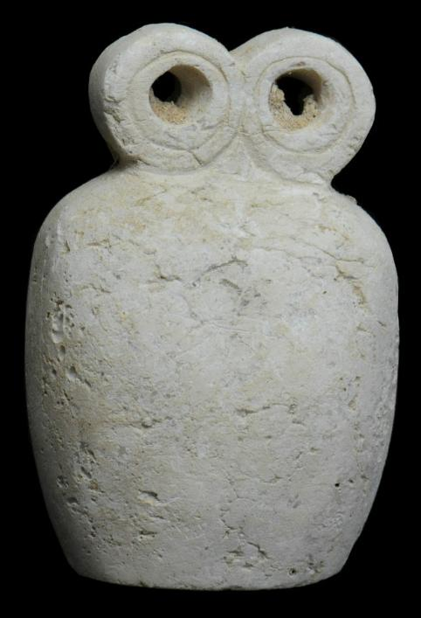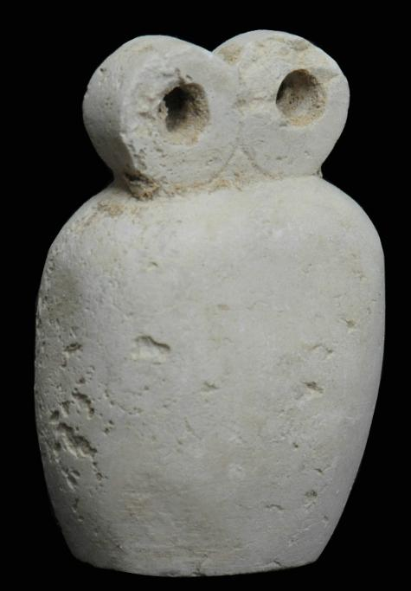

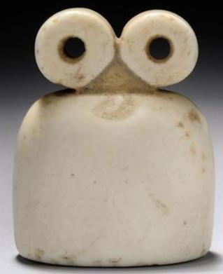

A SYRIAN WHITE STONE SPECTACLE IDOL   
TELL BRAK, CIRCA 4TH MILLENNIUM B.C.   
With bell-shaped body surmounted by two circular perforated 'eyes'   
2 1/8 in. (5.3 cm.) high

Provenance: Gawain McKinley collection, acquired prior to 1996, Christies'.

Price Realized: £8,125 ($12,927)

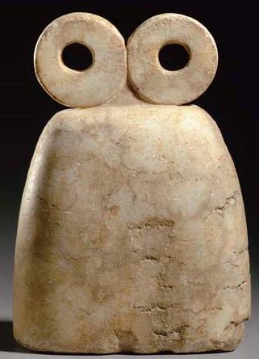

A SYRIAN MARBLE SPECTACLE IDOL   
CIRCA 4TH MILLENNIUM B.C.   
The tall, bell-shaped body with a flat base, tapering toward the top and surmounted by two round perforated "eyes"  
10¾ in. (27.3 cm.) tall

Provenance: German Private Collection, 1980s.

Price Realized  [Christies'.](http://www.christies.com/MyChristies/my_settings_currency.aspx)

$62,400

Sales totals are hammer price plus buyer’s premium and do not reflect costs, financing fees or application of buyer’s or seller’s credits.

Estimate

$12,000 - $18,000

Sale Information

Sale [1846](http://www.christies.com/LotFinder/searchresults.aspx?action=search&intSaleID=21347)   
[Antiquities](http://www.christies.com/LotFinder/searchresults.aspx?action=search&intSaleID=21347)   
8 June 2007   
Christies' New York, Rockefeller Plaza

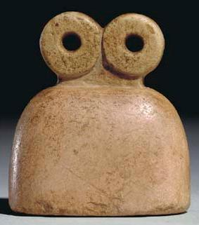

A SYRIAN PINK STONE SPECTACLE IDOL   
TELL BRAK REGION  
CIRCA 4TH MILLENNIUM B.C.  
The bell-shaped body with a short neck, rectangular in section, surmounted by two circular perforated "eyes"  
2 in. (5.1 cm.) high

Provenance

Dr. Elie Borowski.  
French Private Collection, 1970s.

Price Realized [(Set Currency)](http://www.christies.com/MyChristies/my_settings_currency.aspx)

$3,824

Sales totals are hammer price plus buyer’s premium and do not reflect costs, financing fees or application of buyer’s or seller’s credits.

Estimate

$4,000 - $6,000

Sale Information

Sale [1446](http://www.christies.com/LotFinder/searchresults.aspx?action=search&intSaleID=18930)   
  
10 December 2004   
New York, Rockefeller Plaza

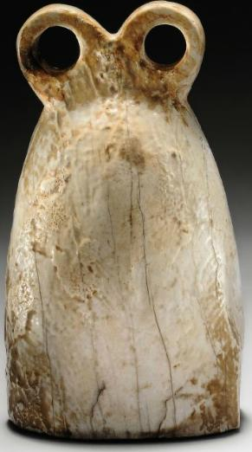

A SYRIAN GYPSUM SPECTACLE IDOL   
TELL BRAK, CIRCA 4TH MILLENNIUM B.C.   
The bell-shaped body oval in section, surmounted by two circular perforated 'eyes'  
4½ in. (11.4 cm.) high

Provenance

Collection of Z. Wolloch, New York, 1960s.  
With Fortuna Fine Arts, New York, 2007 (Venerable Traditions, Works of Art from the Ancient World, no. 2).

Price Realized [(Set Currency)](http://www.christies.com/MyChristies/my_settings_currency.aspx)

£6,875

($10,938)

Sales totals are hammer price plus buyer’s premium and do not reflect costs, financing fees or application of buyer’s or seller’s credits.

Estimate

£6,000 - £8,000

($9,552 - $12,736)

Sale Information

Sale [5488](http://www.christies.com/LotFinder/searchresults.aspx?action=search&intSaleID=22908)   
[Antiquities](http://www.christies.com/LotFinder/searchresults.aspx?action=search&intSaleID=22908)   
7 October 2010   
London, South Kensington   
[Contact the Department](http://www.christies.com/lotfinder/ancient-art-antiquities/a-syrian-gypsum-spectacle-idol-tell-brak-5358332-details.aspx)

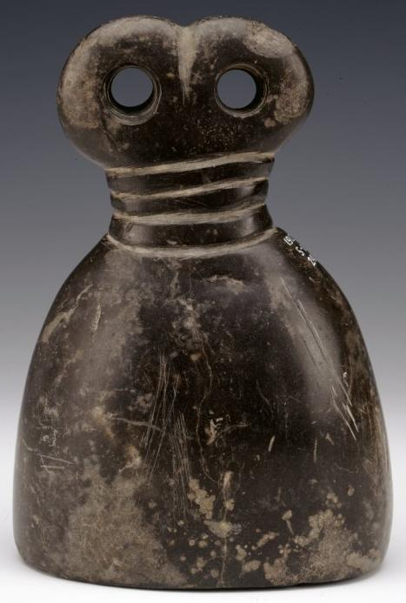

AN175806001

© The Trustees of the British Museum

Department: Middle East

Registration number: 1912,0511.240

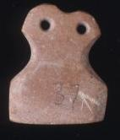

AN235470001

© The Trustees of the British Museum

Department: Middle East

Registration number: 1939,0208.94

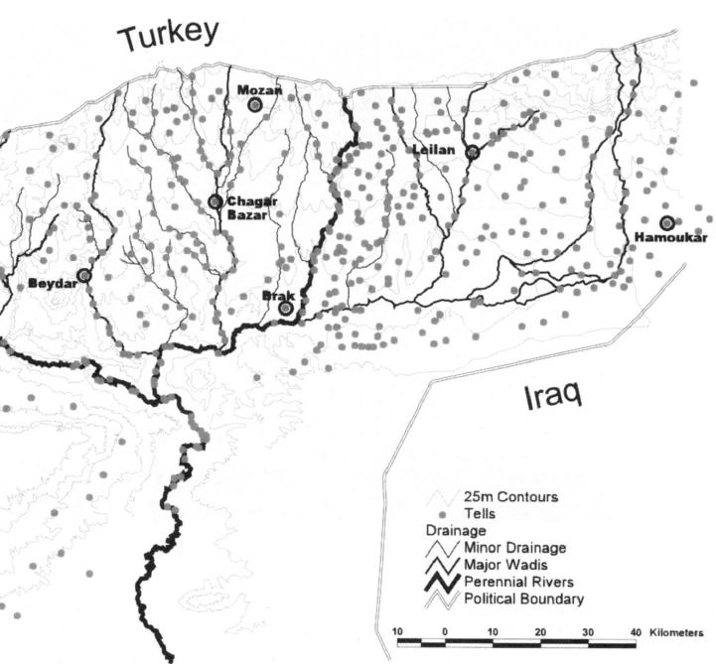

| Shipping details |
| --- |
| **Ralph J Coffman Jr**  149 Atlantic Ave  Swampscott MA 01907-2427  United States |

## Order details

|  |  |  |  |
| --- | --- | --- | --- |
| **Item title** | **Available actions** | **Shipping & handling (estimated delivery*)** | **Price** |

[Printer version](http://payments.ebay.com/ws/eBayISAPI.dll?ViewPaymentStatus&transid=370574287023&userloginid=802-867&printerversion=true&itemid=360587030983)

|  |  |  |
| --- | --- | --- |
| Seller: | [**Member id** galleria-archeologia](http://myworld.ebay.com/galleria-archeologia) ( [**Feedback Score Of** 2519](http://feedback.ebay.com/ws/eBayISAPI.dll?ViewFeedback&userid=galleria-archeologia)) | [Contact seller](http://contact.ebay.com/ws/eBayISAPI.dll?ShowCoreAskSellerQuestion&frm=3998&iid=360587030983&redirect=0&requested=galleria-archeologia) |

|  |  |  |  |  |
| --- | --- | --- | --- | --- |
| Paid on Feb-28-13 via PayPal | | | | |
|  |  |  |  |  |

|  |  |  |  |  |  |  |  |  |
| --- | --- | --- | --- | --- | --- | --- | --- | --- |
|  | [**Item Title:**ANCIENT TEL-BARAK 'EYE' IDOL**- opens in a new window or tab**](http://cgi.ebay.com/ws/eBayISAPI.dll?ViewItem&item=360587030983)  **Item Id:**360587030983 - Price: US $555.00  Quantity:1  Having a problem with this purchase? [We can help](javascript:;) | |  | | --- | |  | | |  |  | | --- | --- | | [Leave feedback](http://feedback.ebay.com/ws/eBayISAPI.dll?LeaveFeedbackShow&useridfrom=802-867&useridto=galleria-archeologia&item=360587030983&transactid=370574287023) |  | | | Expedited Shipping : **US $9.00**  USPS Priority Mail®  Estimated delivery on or before Tue. Mar. 5 | US $555.00 |



|  |  |  |  |  |
| --- | --- | --- | --- | --- |
|  | | |  | |
|  |  | |  |  |  |  |  |  |  |  |  |  |  |  |  |  |  |  |  |  | | --- | --- | --- | --- | --- | --- | --- | --- | --- | --- | --- | --- | --- | --- | --- | --- | --- | --- | | |  | | --- | | |  |  |  |  |  |  |  |  |  |  |  |  |  |  |  | | --- | --- | --- | --- | --- | --- | --- | --- | --- | --- | --- | --- | --- | --- | --- | | |  |  | | --- | --- | | Subtotal: | US $555.00 | |  | | | Shipping & handling: | US $9.00 | |  | | |  | | |  | | | Total: | US $564.00 | | | | | |  |